F.C.P.A.

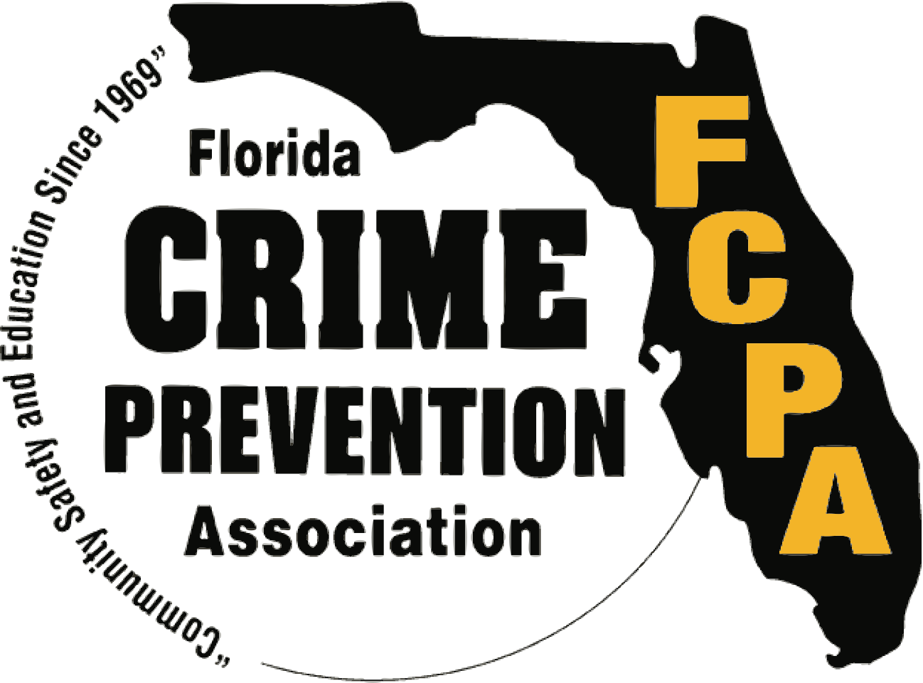
Award Nomination Packet

55th Annual Crime Prevention Training Conference Presented by the
Florida Crime Prevention Association October 21st – October 25th, 2024

Sandestin Golf & Beach Resort
9300 Emerald Coast Pkwy
Miramar Beach, FL 32550

A copy of the “Award Nomination Categories” page and the “Nomination Contact Information” page must accompany EACH nomination.

Award Nomination Categories
Check one:

o Category A

Outstanding Crime Prevention Program
o Category B

Crime Prevention Volunteer of the Year
o Category C

Crime Prevention Unit of the Year (Large Agency – 100+ sworn)
o Category D

Crime Prevention Unit of the Year (Small Agency – Less than 100
sworn)
o Category E

Crime Prevention Practitioner of the Year
o Category F
Lifetime Achievement Award (This award is presented solely at the discretion of the FCPA Board of Directors to a person who has spent at least ten (10) years in the Crime Prevention field and has proven their dedication to the area of Crime Prevention. See Category E, page 9, for additional information about this award)

Nomination Contact Information

Name of Person or Group Being Nominated

Name / Agency / Business Name: Address:
Telephone #: Fax #:
Email:

Nominated By

Name:

Agency / Business: Address: Telephone:
Fax #: Email:

NOTE: This nomination form replaces all previous forms. No other form or award will be considered or accepted.
2024 Award Categories & Nomination Criteria

The Florida Crime Prevention Association (FCPA) is accepting nominations for the 2024 Crime Prevention Awards Program that will be held in conjunction with the annual statewide crime prevention training conference. This year’s conference will be held at the Sandestin Golf & Beach Resort, 9300 Emerald Coast Pkwy, Miramar Beach, Fl 32550.

The nominated person, organization, agency, or business does not have to be a member of the FCPA to be eligible for an award, with the exception of the Crime Prevention Practitioner of the Year and the Lifetime Achievement award (see individual award categories below for specifics about the awards).

Awards will be presented at the FCPA Awards Ceremony Dinner, held Thursday, October 24, 2024, during the conference.

NOMINATIONS MUST BE RECEIVED NO LATER THAN MONDAY, AUGUST 23, 2024

Winners will be notified by September 13, 2024.
Winners may be contacted after the announcement for pictures and additional information.
Winners and their guests (3 each) will be invited to attend the Award Ceremony FREE to receive their honors.

The packet along with supporting documents must be emailed to:
fcpa.awards@gmail.com

All nominations will receive a confirmation. If no confirmation is received, contact Shawn Strickland at sstrick2007@outook.com or 904-630-8036.

IMPORTANT GUIDELINES:
*****PLEASE NOTE THE GUIDELINES FOR THIS YEAR’S NOMINATIONS HAVE CHANGED*****

Please limit each nomination to 500 words or less. You will be contacted if more information is needed.

The Nomination Form (pages 2 & 3) of this packet must be completed and attached to each nomination submitted.

No videos, booklets, or notebooks please. All materials become the property of the FCPA and will not be returned. If your nomination is chosen, the Awards Committee will then contact you to request accompanying photos, videos, or supplemental information.

This year we will not require letters of recommendation.

Category A

Outstanding Crime Prevention Program
Every year new crime prevention programs are developed or old ones revitalized and given new direction. A new or improved program stands out like a shining star and should be rewarded.

Eligible:

- Any law enforcement agency

- Any governmental agency

- Any community-based organization

Nomination Criteria:

- Any law enforcement agency, governmental agency or community-based organization that has developed a new crime prevention program or re-vamped an existing one during the previous 12 months*

- The nomination can be made by any member of the agency or organization who implemented the program or by someone having knowledge of the program.

- Nomination to include:

  - Name of the agency or organization who implemented the program

  - Date the program was implemented

  - Crime problem targeted

  - Effectiveness of program

- Previous 12 months means 12 months prior to the awards due date

Category B

Crime Prevention Volunteer of the Year
This award offers special recognition for the outstanding and uncompensated efforts of someone who volunteers their time to a law enforcement crime prevention unit or crime prevention-related initiative and who is not employed either full or part-time by that agency or initiative.

Eligible:

  - Any volunteer of a law enforcement agency or crime prevention-related initiative.

Nomination Criteria:

  - Any person who volunteers for a Florida law enforcement agency’s crime prevention unit or a crime prevention-related initiative for the previous 12 months* is eligible for this award

  - Nomination must be made by someone within the agency or initiative

  - Nomination must list a description of the assignments completed by the volunteer including:

    - Agency or initiative name and volunteer’s total years of service in crime prevention

    - Community or area served by the volunteer

    - Number of hours and programs the volunteer personally participated in during the previous 12 months*

- Previous 12 months means 12 months prior to the awards due date

Category C

Crime Prevention Unit of the Year (Agency – 100+ Sworn)
This award recognizes the special efforts and exceptional accomplishments performed by an agency’s crime prevention unit during the previous 12 months*.

Eligible:

  - Any crime prevention unit from an agency with 100+ sworn members

Nomination Criteria:

  - Any law enforcement agency’s crime prevention unit whose function is to serve the crime prevention needs of their governmental jurisdiction within the State of Florida can be nominated

  - The nomination can be made by either a member of the unit or by someone having knowledge of the unit’s accomplishments

  - The nomination must include:

    - Law enforcement agency’s name and address

    - The unit’s chain of command and the members assigned to the unit

    - Number of total sworn officers employed by the agency

    - List of accomplishments during the previous 12 months*

- Previous 12 months means 12 months prior to the awards due date

Category D

Crime Prevention Unit of the Year (Agency – Less than 100 Sworn)
This award recognizes the special efforts and exceptional accomplishments performed by an agency’s crime prevention unit during the previous 12 months*.

Eligible:

  - Any crime prevention unit from an agency with less than 100 sworn members

Nomination Criteria:

  - Any law enforcement agency’s crime prevention unit whose function is to serve the crime prevention needs of their governmental jurisdiction within the State of Florida can be nominated

  - The nomination can be made by either a member of the unit or by someone having knowledge of the unit’s accomplishments

  - The nomination must include:

    - Law enforcement agency’s name and address

    - The unit’s chain of command and the members assigned to the unit

    - Number of total sworn officers employed by the agency

    - List of accomplishments during the previous 12 months*

- Previous 12 months means 12 months prior to the awards due date

Category E

Crime Prevention Practitioner of the Year
This award recognizes the outstanding efforts of a Florida Crime Prevention Practitioner for his or her contributions and outstanding performance in the field of crime prevention during the previous 12 months*

Eligible:

  - Any law enforcement employee

Nominee must hold the designation Florida Crime Prevention or CPTED Practitioner

  - Nominee must be a member in good standing of the Florida Crime Prevention Association

Nomination Criteria:

  - Any law enforcement employee who holds a Florida Crime Prevention or CPTED Practitioner designation and is an FCPA member in good standing is eligible for this award

  - The nomination can be made by any member of the agency employing the practitioner or by someone having knowledge of the practitioner’s work

  - Nomination to include:

    - Name, rank and years of service in crime prevention

    - Description of the outstanding work accomplishments during the previous 12 months*

    - Community group/area served by the practitioner

    - List of the programs and responsibilities of the practitioner during this time frame

- Previous 12 months means 12 months prior to the awards due date.

Category F

Lifetime Achievement Award
This award recognizes any Crime Prevention Practitioner who has spent the majority of their career in the Crime Prevention field and has proven their dedication to the area of Crime Prevention and the FCPA’s crime prevention ideals.

Eligible:

  - Any law enforcement employee

  - Any business employee

Nominee must hold the designation Florida Crime Prevention Practitioner and have been working in that capacity for a minimum of 10 years.

  - Nominee must be a member of the Florida Crime Prevention Association

Nomination Criteria:

  - Any law enforcement employee, business employee, employed full time, either sworn or non-sworn, and who holds a Florida Crime Prevention Practitioner designation and is a FCPA member in good standing is eligible for this award.

  - The nomination can be made by any member of the agency or business employing the Practitioner, or by someone having knowledge of the Practitioners work.

  - Nomination must include:

    - Name, rank and years of service in crime prevention

    - Description of the outstanding work accomplished during the Crime Prevention career

    - Community group/area served by the Practitioner

    - List of the programs and responsibilities of the Practitioner during their career.

